**Project Design Phase-II**

**Data Flow Diagram & User Stories**

|  |  |
| --- | --- |
| Date | 06 November 2022 |
| Team ID | PNT2022TMID01972 |
| Project name | Project -Emerging method for early detection of forest fire |
| Maximum marks | 4 Marks |

**DATA FLOW DIAGRAMS**:

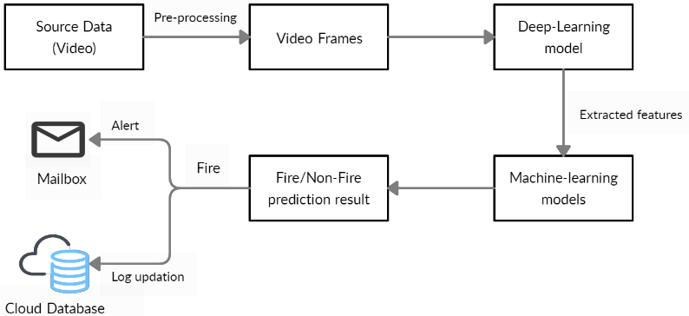

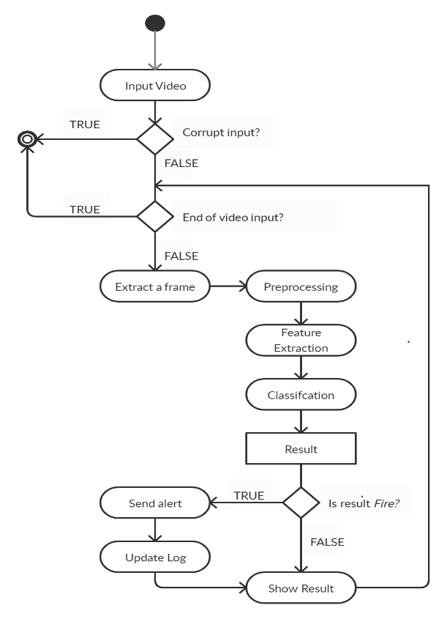

User stories:

Use the below template to list all the user stories for the product

|  |  |  |  |  |  |  |
| --- | --- | --- | --- | --- | --- | --- |
| User Type | Functional Requirement  (Epic) | User Story Number | User Story/Task | Acceptance criteria | Priority | Release |
| People who live near forest | Login | USN-1 | As a lively hood, I want to inform the (forest fire) situation to the government. And to protect myself and my family from the forest fire. | I can use my mobile phone and I can inform the situation. | High | Sprint-1 |
| Forest officer | Login | USN-1 | As the forest officer, I want to identify the forest fire in early | I can identify the fire by using cameras. And sensors. | High | Sprint-1 |
| Tourist / Trekking people | Login | USN-1 | As the humanity based activity, I want to inform and protect myself and the people, animals and others from forest fire | I can use my mobile phone and I can inform the situation. | High | Sprint-1 |
| Passers-by | Login | USN-1 | As the humanity based activity, I want to inform and protect the people, animals and others from forest fire | I can use my mobile phone and I can inform the situation. | High | Sprint-1 |